Create an Agent with the New Experience (Copilot Studio)

Lab Objective

By the end, learners will:
- Create an agent using the new Copilot Studio experience
- Define instructions (role, tone, behaviour)
- Add knowledge sources
- Test and refine the agent
______________________________________________________________________

Step 1 — Create Your First Agent (Core Setup)

Scenario
Build a Training Assistant Agent for internal learners.

Steps
1. Open Copilot Studio.
2. Click Agent → New Agent.

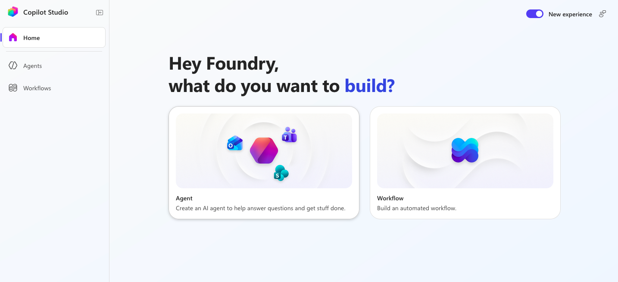
3. Enter:
- Name: Training Assistant

4. In Instructions, add:
```
You are a helpful training assistant.
Provide clear learning paths and recommend courses.
Keep responses concise and friendly.
```
5. Click Save
Exercise
👉 Ask: Suggest a learning plan for Power Automate.
👉 Observe tone and response quality

Step 2 — Enhance Agent Behaviour (Instructions Engineering)

Goal - Improve responses using better instructions

Update Instructions:

```
- Act as a corporate trainer
- Provide step-by-step learning plans
- Recommend Microsoft Learn resources
- Ask clarifying questions if needed
```

Exercise

👉 Compare responses before vs after
👉 Identify improvement areas

Step 3 — Add Knowledge Sources

Goal - Make agent context-aware

1. Go to **Build tab → Knowledge**
2. Add:
Public website (e.g., Microsoft Learn) - https://learn.microsoft.com/en-gb/
3. Save changes

Exercise
👉 Ask: What trainings are available?

Step 4 — Test & Debug (Preview Mode)

1. Open Preview tab
2. Run multiple prompts:
* Beginner question
* Advanced question
3. Refine instructions if needed

Step 5 — Optimise & Evaluate

Goal - Improve quality using evaluation tools

1. Go to Evaluate tab
2. Create test prompts:
* Training queries
* Knowledge-based questions
3. Review output quality

Customize Agent Settings

* Change **language**
* Modify **schema name**
* Adjust behaviour settings

References
- Create an agent with the new experience
https://learn.microsoft.com/en-us/microsoft-copilot-studio/agents-experience/authoring-first-bot

- Agents overview (new experience)
https://learn.microsoft.com/en-us/microsoft-copilot-studio/agents-experience/overview
- Copilot Studio First Agent Lab (Developer Camp)
https://microsoft.github.io/copilot-camp/pages/make/copilot-studio/01-first-agent/

- https://learn.microsoft.com/en-us/microsoft-copilot-studio/agents-experience/authoring-first-bot#create-an-agent-with-the-new-experience

